Before You Read

Are teachers honoured in your country?
When is the Teacher's Day in your country?
Look at the picture
What do you see?
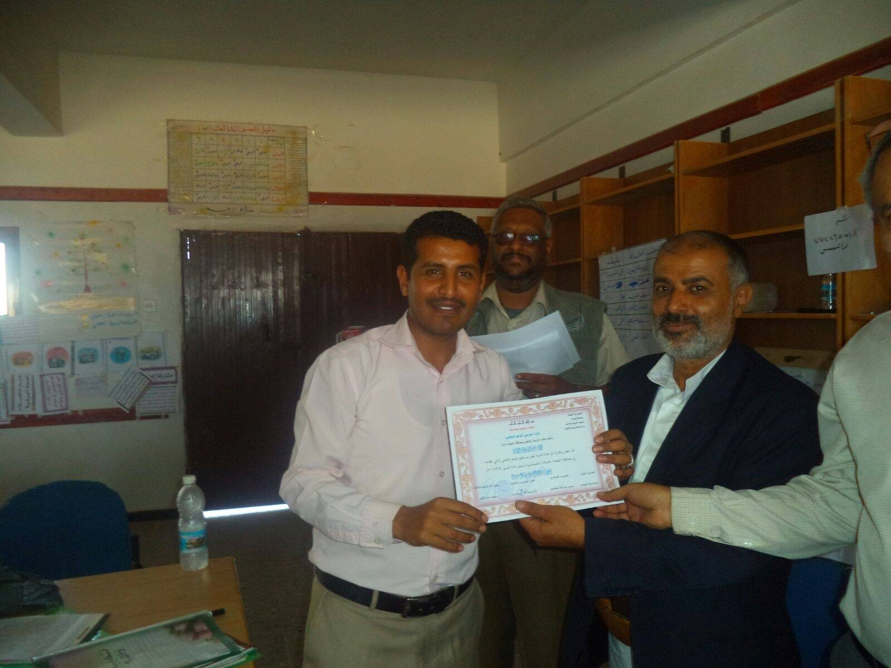
Teacher's Day(s )in Yemen
Teachers' Day in Yemen ,as in other many countries ,is a special day for the appreciation of teachers. This includes celebrations to honour teachers for their special contributions in enhancing the educational process in the country. The date on which Teachers' Day is celebrated seems to be different in Yemen. Apart from Teachers' days in different countries distinct from World Teachers' Day, which is celebrated on 5th October, Yemeni schools prefer to celebrate this day during April. Though, it is officially stated that the Teacher's Day should be on 28th February as so many Arab countries decided together to make it a day for Arab teachers. Hence, there is no exact day to make it happen. Schools are left independent to choose the right day during April to honour their teachers on condition that it must be done within April yearly.

As schools are independent in determining the date on which they celebrate Teacher's Day, they are also have their own independent ideas to celebrate the special day. For example, private schools have more capacity to invite local newspaper reporter or editorial writer, or a local TV news personality, to attend the party as a media coverage, and then to publish or air the events on what being teachers are honoured that day.
In-state schools do not miss such opportunity. They usually find support from governmental authorities or community leaders in the matter of visiting schools and honouring the teachers. This really means a lot to school administrations and teachers as well . Being honoured by a governmental official.or a local leader adds to the celebration a fanciful taste.
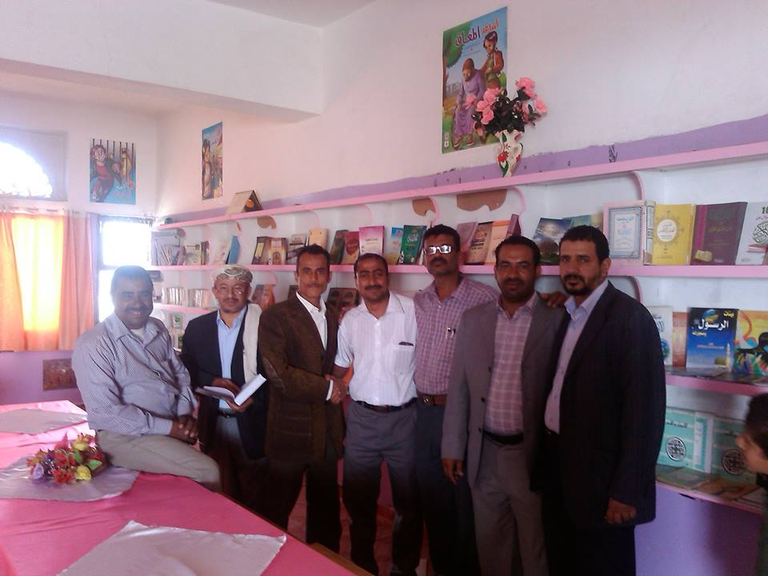
Honouring teachers take many forms. Mostly teachers receive Thank You teachers. They are usually given presents from students or from their parents. A few years ago Ministry of Education has started to officialise the occasion by organising annually honouring parties for a group of teachers who are nominated by their educational regions for their good achievements. By and large, teachers feel re-energised to do their best when they are remembered and honoured by society.

AFTER YOU READ
-When do schools in Yemen celebrate Teacher's Day?
- How does society honour teachers?
- Is the date of Teacher's Day in Yemen similar to your country?
- What ideas do you think they are good to do to honour teachers?

